**COMP1350 Assignment**

**Group Number:**

|  |  |
| --- | --- |
| Student ID | Student Name |
| 46978518 | Tyler Johnson |
| 48439401 | Fadila Tahsina |
| 48283665 | Xian Hui Cai |
| 48340979 | MD Tanjil Alam Emon |
| 48645265 | Maskatul Hasan Alif |

**Solutions:**

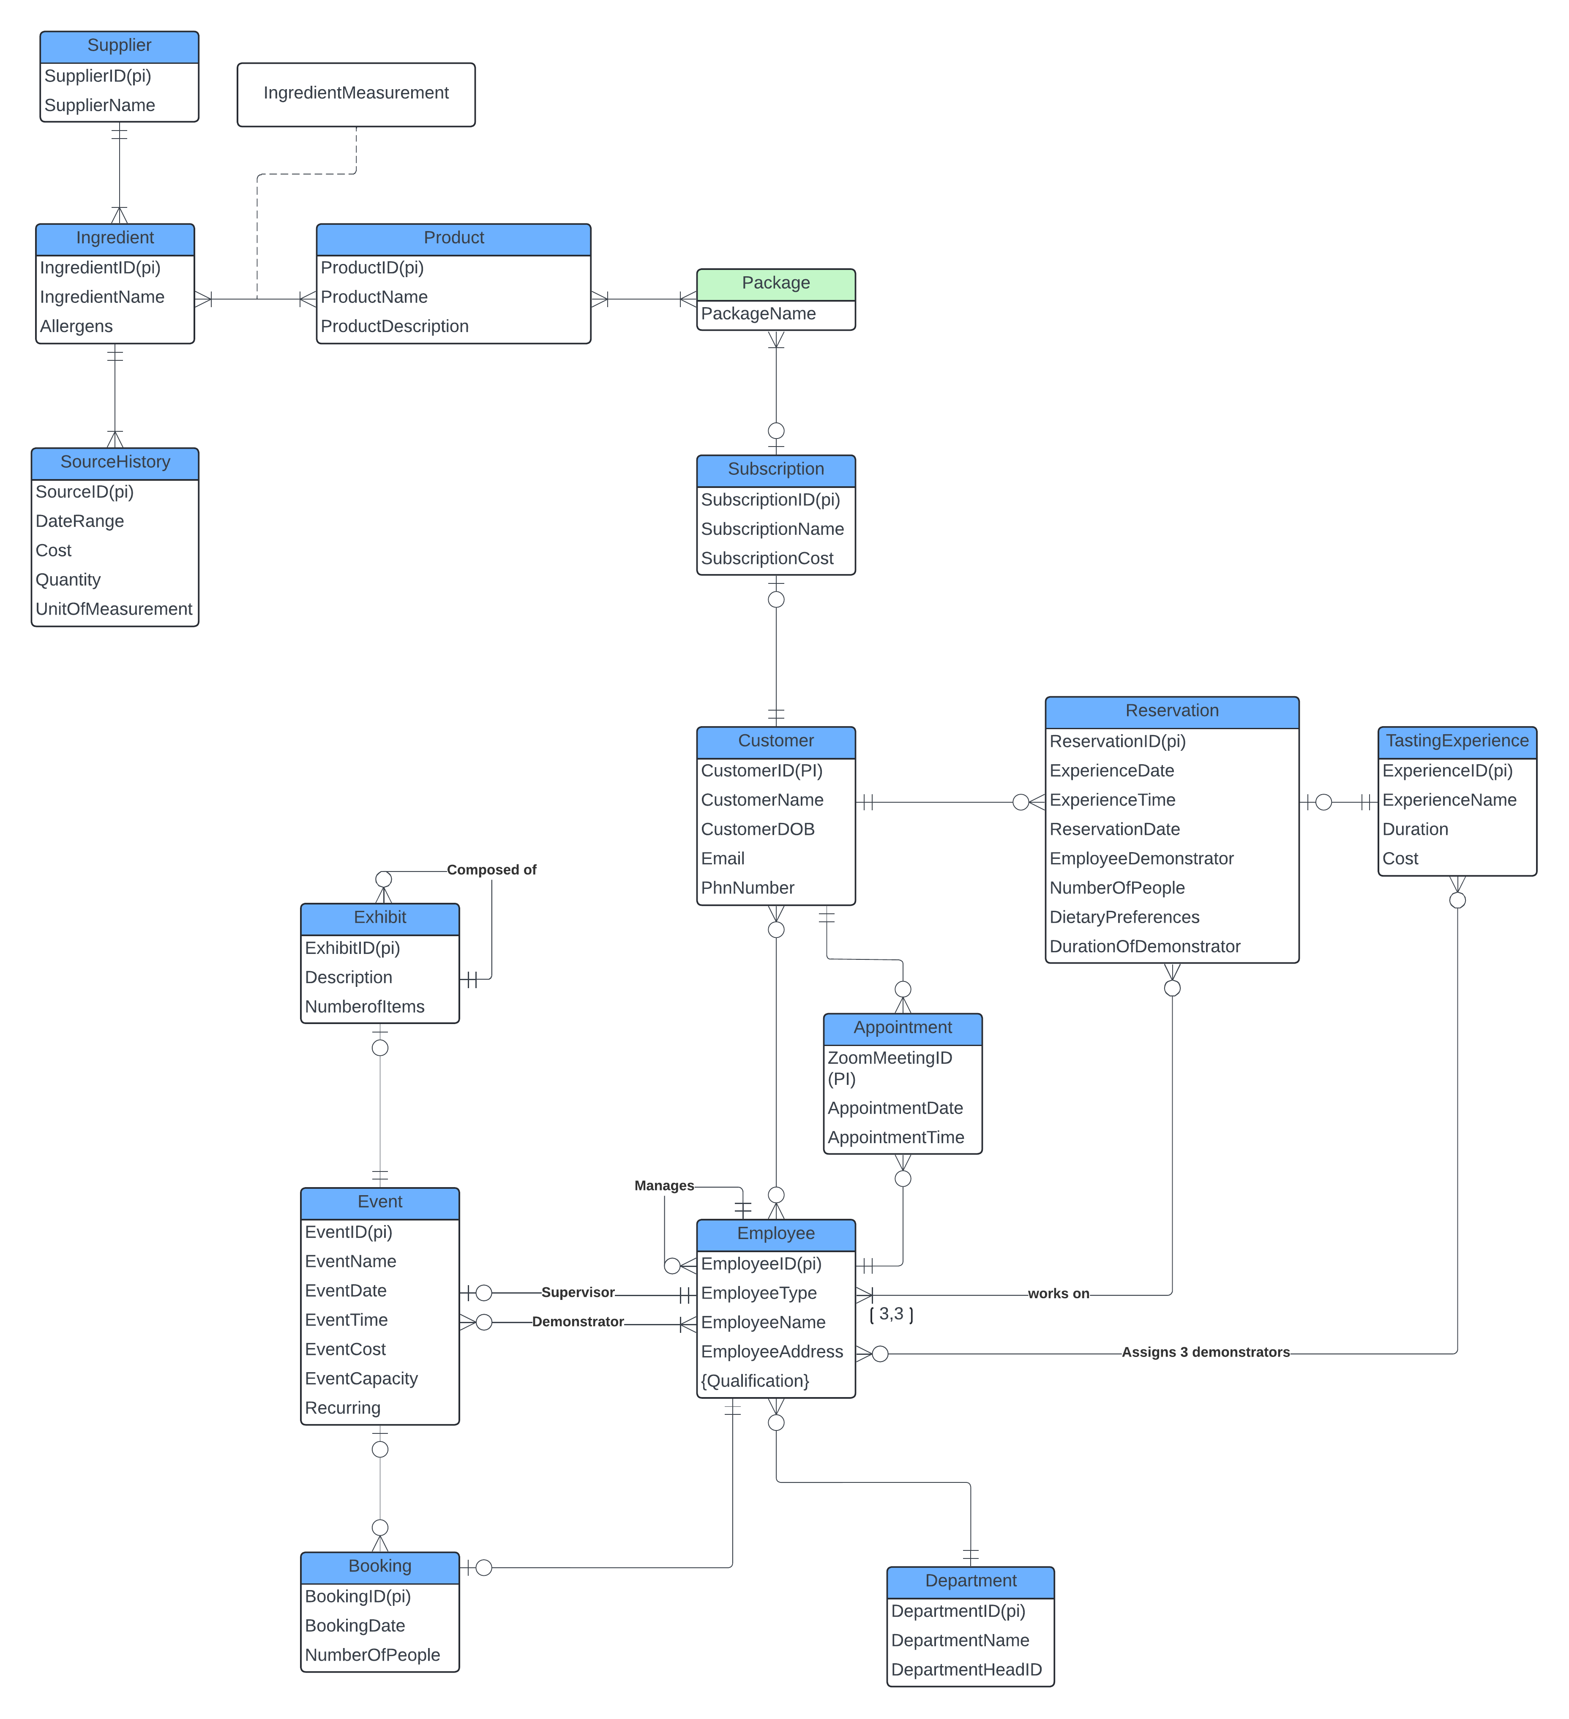Task 1:

Task 2:

**Step 1: Entities**

Subscription(SubscriptionID(pk), SubscriptionName, SubscriptionCost)

Package(PackageID(pk), PackageName)

Supplier(SupplierID(pk), SupplierName)

Customer(CustomerID(pk), CustomerName, CustomerEmail, CustomerPhNum, DateOfBirth)

Exhibit(ExhibitID(pk), Description, NumberOfItem)

Product(ProductID(pk), ProductName, ProductDescription)

Department(DepartmentID(pk), DepartmentName)

Employee(EmployeeID(pk), EmployeeType, EmployeeName, EmployeeAddress)

Ingredient(IngredientID(pk), IngredientName, Allergens)

SourceHistory(SourceID(pk), StartDate, EndDate, Cost, Quantity, UnitOfMeasurement)

Appointment(AppointmentID(pk), AppointmentDateTime)

Reservation(ReservationID(pk), ReservationDateTime, NumberOfPeople, DurationOfDemonstrator, DietaryPreferences)

TastingExperience(ExperienceID(pk), ExperienceName, Duration, Cost)

eEvent(eEventID(pk), eEventName, eEventDateTime, eEventCost, eEventCapacity, Recurring)

Booking(BookingID(pk), BookingDateTime, NumberOfPeople)

**Step 2: Weak Entities**

No weak entities identified.

**Step 3: 1-to-1 Relationships**

Department(DepartmentID(pk), DepartmentName, HeadEmployeeID(fk))

CustomerSubscription(CustomerID(pk), SubscriptionID(fk))

**Step 4: 1-to-N Relationships**

Employee(EmployeeID(pk), EmployeeType, EmployeeName, EmployeeAddress, DepartmentID(fk), ManagerID(fk))

Ingredient(IngredientID(pk), IngredientName, Allergens, SupplierID(fk))

SourceHistory(SourceID(pk), StartDate, EndDate, Cost, Quantity, UnitOfMeasurement, IngredientID(fk), SupplierID(fk))

Appointment(AppointmentID(pk), AppointmentDateTime, EmployeeID(fk), CustomerID(fk))

Reservation(ReservationID(pk), ReservationDateTime, NumberOfPeople, DurationOfDemonstrator, DietaryPreferences, CustomerID(fk))

TastingExperience(ExperienceID(pk), ExperienceName, Duration, Cost, ReservationID(fk))

eEvent(eEventID(pk), eEventName, eEventDateTime, eEventCost, eEventCapacity, Recurring, EmployeeID(fk), ExhibitID(fk))

Booking(BookingID(pk), BookingDateTime, NumberOfPeople, EmployeeID(fk), eEventID(fk), CustomerID(fk))

**Step 5: M-to-N Relationships**

SubscriptionPackage(SubscriptionID(pk fk), PackageID(pk fk))

PackageProduct(PackageID(pk fk), ProductID(pk fk))

IngredientMeasurement(IngredientID(pk fk), ProductID(pk fk), Measurement, UnitOfMeasurement)

ReservationDemonstrator(ReservationID(pk fk), EmployeeID(pk fk))

WorksOn(ExperienceID(pk fk), EmployeeID(pk fk))

ExhibitComposition(ParentExhibitID(pk fk), ChildExhibitID(pk fk))

Demonstrate(EmployeeID(pk fk), eEventID(pk fk), Role)

HelpOut(CustomerID(pk fk), EmployeeID(pk fk))

cContains(ProductID(pk fk), IngredientID(pk fk))

**Step 6: Multivalued Attributes**

EmployeeQualification(EmployeeID(pk fk), EmployeeQualification(pk))

**Step 7: n-ary Relationships**

No n-ary relationships identified.

**Final Compiled List of All Tables in Their Most Up-To-Date Form**

* Subscription(SubscriptionID(pk), SubscriptionName, SubscriptionCost)
* Package(PackageID(pk), PackageName)
* Supplier(SupplierID(pk), SupplierName)
* Customer(CustomerID(pk), CustomerName, CustomerEmail, CustomerPhNum, DateOfBirth)
* Exhibit(ExhibitID(pk), Description, NumberOfItem)
* Product(ProductID(pk), ProductName, ProductDescription)
* Department(DepartmentID(pk), DepartmentName, HeadEmployeeID(fk))
* Employee(EmployeeID(pk), EmployeeType, EmployeeName, EmployeeAddress, DepartmentID(fk), ManagerID(fk))
* Ingredient(IngredientID(pk), IngredientName, Allergens, SupplierID(fk))
* SourceHistory(SourceID(pk), StartDate, EndDate, Cost, Quantity, UnitOfMeasurement, IngredientID(fk), SupplierID(fk))
* Appointment(AppointmentID(pk), AppointmentDateTime, EmployeeID(fk), CustomerID(fk))
* Reservation(ReservationID(pk), ReservationDateTime, NumberOfPeople, DurationOfDemonstrator, DietaryPreferences, CustomerID(fk))
* TastingExperience(ExperienceID(pk), ExperienceName, Duration, Cost, ReservationID(fk))
* eEvent(eEventID(pk), eEventName, eEventDateTime, eEventCost, eEventCapacity, Recurring, EmployeeID(fk), ExhibitID(fk))
* Booking(BookingID(pk), BookingDateTime, NumberOfPeople, EmployeeID(fk), eEventID(fk), CustomerID(fk))
* CustomerSubscription(CustomerID(pk), SubscriptionID(fk))
* SubscriptionPackage(SubscriptionID(pk fk), PackageID(pk fk))
* PackageProduct(PackageID(pk fk), ProductID(pk fk))
* IngredientMeasurement(IngredientID(pk fk), ProductID(pk fk), Measurement, UnitOfMeasurement)
* ReservationDemonstrator(ReservationID(pk fk), EmployeeID(pk fk))
* WorksOn(ExperienceID(pk fk), EmployeeID(pk fk))
* ExhibitComposition(ParentExhibitID(pk fk), ChildExhibitID(pk fk))
* Demonstrate(EmployeeID(pk fk), eEventID(pk fk), Role)
* HelpOut(CustomerID(pk fk), EmployeeID(pk fk))
* cContains(ProductID(pk fk), IngredientID(pk fk))
* EmployeeQualification(EmployeeID(pk fk), EmployeeQualification(pk))